2023 TFRW CONVENTION
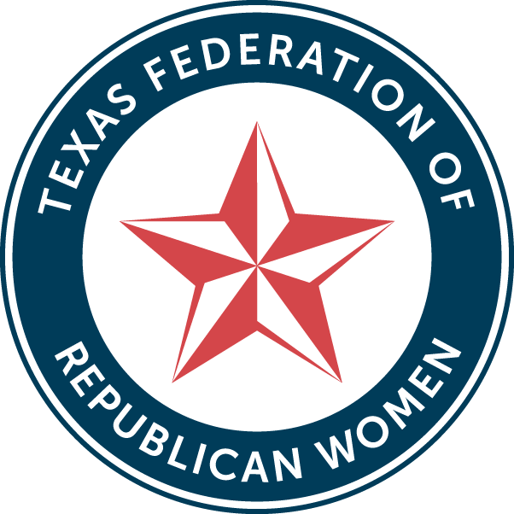
ELECTED OFFICIALS & CANDIDATES MEET & GREET

Thursday, October 12, 2023 9:30 a.m. until 11:30 a.m.
Irving Convention Center, Jr. Ballroom C-D (third floor) Irving, Texas

Great Opportunity for one-on-one conversations with TFRW Convention Attendees.
Display Tables $250.00
Limited Space Available (30 Available) Reservation Deadline is August 31, 2023

For questions or additional information, please contact:
Kellye Duncan Garrett at: Phone: 325-315-6484 or Email: kellye3160@yahoo.com

Meet & Greet Table Reservations

Elected Official__________ Candidate__________

Name for Table Tent________________________________________________________________________

Name:___________________________________________________________________________________

Office Held/Seeking:________________________________________________________________________

Contact Person:___________________________________________________________________________

Email:___________________________________________________________________________________

Phone:__________________________________________________________________________________

Alternate Phone:___________________________________________________________________________

Purchaser's Name:_________________________________________________________________________

Phone if different:__________________________________________________________________________

Mailing Address:___________________________________________________________________________
City:_______________________________________________State:__________________Zip:____________

Purchaser's Email:_________________________________________________________________________

Occupation/Employer:______________________________________________________________________

A standard size rectangular Covered Table (black tablecloth) will be provided. Candidate to provide all campaign materials Space is limited to first 30 paid reservations. This event takes place on the first day of convention in the morning. Opening session for convention begins at 1 PM. Candidates are expected to be present for the full time of the Candidate Meet and Greet.

Make Checks Payable to:
TFRW Convention 2023 PAC

Mail Check to:
TFRW Convention 2023 PAC
c/o Kerry Gaines, PAC Treasurer
2113 Flat Creek Drive
Richardson, TX 75080-2331

Political ad paid for by TFRW Convention 2023 PAC. 13740 N. Highway 183, Suite J4, Austin, TX 78750-1832, a non-profit organization under Section 527 of the Internal Revenue Code. Contributions to TFRW Convention 2023 PAC are not tax deductible as charitable contributions for federal income tax purposes. Corporate contributions are not allowed. Not authorized by any candidate or committee.

