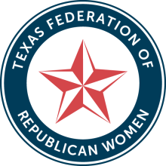 | TEXAS FEDERATION OF REPUBLICAN WOMEN  2021 Biennial Convention | October 13-16, 2021 | 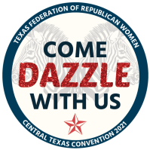
Please indicate the sponsorship level you are selecting. Review the descriptions provided for each package for the total features included.

Sponsorships Available:
$20,000 Zebra Dazzle
$15,000 Elephant Parade
$10,000 Lion Pride
$7,500 Giraffe Kaleidoscope
$5,000 Eagle Congregation
$2,500 Cheetah Coalition
$1,500 Flamboyant Flamingo
* Sponsor packages reflect the total features for each package. All Sponsors are recognized in the TFRW Convention Souvenir Program. The deadline to email your logo and advertisement is August 15th to meet the print date.

Additional Program Ads (Artwork/Ad to be provided by purchaser)
$1800 Full Page Color 7.38“ X 11”
$1400 Full Page Black & White 7.38” X 11”
$925 Half Page Color 7.45” X 5.5” horizontal or 3.75” X 11” vertical
$725 Half Page Black & White 7.45” X 5.5” horizontal or 3.75” X 11” vertical
$700 Quarter Page Color 2.38” X 7.38” horizontal or 3.69” X 5.94” vertical
$500 Quarter Page Black & White 2.38” X 7.38” horizontal or 3.69” X 5.94” vertical

Elected Official Candidate Other
Name:
Office Held/Seeking (if applicable):
Email: Phone:
Address:
City, State, Zip:
Occupation (required):
Make a copy for your records.
Please note that we are able to accept checks from individuals and PACs but not from corporations.

Make Checks Payable to: TFRW Convention 2021 PAC and Mail Check to Texas Federation of Republican Women, ATTN: SPONSORS/ADS Berger, PO Box 171146, Austin, TX 78717-0041
Political ad paid for by TFRW Convention 2021 PAC, 13740 N. Highway 183, Suite J4, Austin, TX 78750-1832, a non-profit organization under Section 527 of the Internal Revenue Code. Contributions to TFRW Convention 2021 PAC are not tax deductible as charitable contributions for federal income tax purposes. Corporate contributions are not allowed. Not authorized by any candidate or committee.

